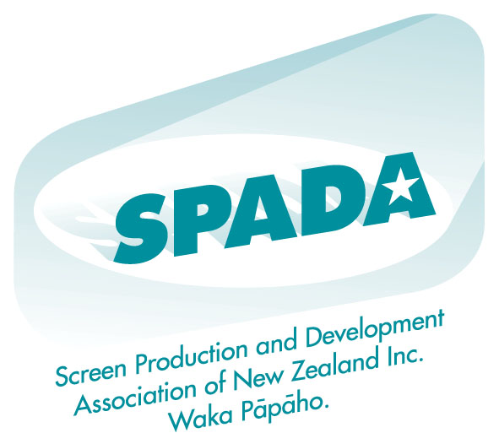

07 June 2007

Jane Kominik
Deputy Chief Executive
Ministry for Culture and Heritage
PO Box 5364
WELLINGTON

Dear Jane

Feedback sought on cultural diversity convention

Thank you for your letter of 07 May 2007, seeking feedback on whether or not New Zealand should become Party to (or ‘accede to’) the UNESCO Convention for the Protection and Promotion of the Diversity of Cultural Expressions.

Response/Comments

Do you agree or disagree that New Zealand should accede to the Convention?
Parties to the Convention are required to cooperate to promote and protect cultural diversity - a remit which SPADA strongly endorses and the New Zealand Government’s ongoing support of the concept of the Convention, culminating in it taking the necessary steps to accede to the Convention.

Advantages and disadvantages for New Zealand to accede to this Convention
SPADA cannot see any apparent disadvantages to joining the Convention. Due to the fact the terms of the Convention are non-binding tangible advantages may be difficult to quantify or measure. However, further to the establishment of “the fund” as outlined under Article 18 – International Fund for Cultural Diversity, it would be useful for non-profit organizations such as SPADA to fully understand the use of resources of the Fund; and what guidelines the Intergovernmental Committee will be following when decisions are being made regarding the allocation of the monies held in the trust.

Economic, social, cultural and environmental effects of the Convention entering force in New Zealand
We are fortunate to live in a country where the Prime Minister is also the Minister for Arts, Culture and Heritage. In undertaking this role, the Prime Minister clearly signals her commitment to the cultural health of New Zealand.

SPADA’s commitment lies in developing a sustainable and commercially successful creative and professional New Zealand screen production industry in a stable and coherent economic environment both nationally and abroad. It also strives for a vibrant, professional and ethical screen production industry, which communicates the diversity of New Zealand screen culture.

Further to SPADA’s understanding of the document titled, Convention on the Protection and Promotion of the Diversity of Cultural Expressions (Paris, 20 October 2005), we are unable to comment on the long term economic, social, cultural or environmental effects of the Convention entering force in New Zealand. As a non-binding Convention it will be up to the governing party at the time to implement what they see as appropriate to ensure the cultural wellbeing of New Zealand continues to be nurtured and supported.

Yours sincerely

Penelope Borland
CEO, SPADA

